3rd Symposium on The Acoustics of Ancient Theatres: Paper Guidelines

First Author^{1(*)}; Second Author^{2,3}; Third Author³

¹ Department of Theoretical Innovations, University of Example Studies, Somewhere, UK
² Institute of Advanced Placeholder Research, Sample City, Canada
³ Centre for Academic Formatting Excellence, Demo University, Australia

ABSTRACT
This document provides guidelines for authors submitting papers to the Proceedings of the 3rd Symposium on the Acoustics of Ancient Theatres. The conference proceedings will be published online at https://www.eaa-saat.eu/. All submissions must strictly follow the formatting instructions provided in this template and be submitted as PDF (Portable Document Format) files. The inclusion of an abstract is mandatory. It must not exceed 200 words (including spaces) and should clearly summarise the main objectives, methods, and findings of the paper. The abstract must not include equations, figures, numbered references, or footnotes.
Keywords: Insert up to three keywords separated by commas, in italics and lowercase. Keywords are mandatory.

INTRODUCTION
Authors are requested to use this document as a guideline when preparing their manuscripts in order to ensure consistency and uniformity across all papers included in the Proceedings. Only manuscripts written in English will be considered for publication.
The length of each paper must not exceed four pages. The exclusive use of the International System of Units (SI) is mandatory. Where non-SI units are used, their SI equivalents must be provided in parentheses, e.g., 25.4 mm (1 in). The Organising Committee reserves the right to reject any manuscript deemed unsuitable for inclusion in the Proceedings, even if the abstract has been previously accepted.

MANUSCRIPT FORMAT

Margin Settings
All conference papers must be prepared using A4 paper size, with all margins set to 15 mm. These settings, along with other formatting parameters, are automatically configured when using this Microsoft Word template.
Page numbers must not be inserted. Authors should not modify the headers or footers, nor include any additional content in these areas, except for footnotes containing email addresses on the first page of the manuscript.

First Page Heading
This document serves as a template; therefore, all required logos are already included. The Symposium logo must appear only at the top of the first page, while the organisers’ logos must appear only at the bottom of the first page. Logos must not be included on subsequent pages.

(*) Corresponding author: first.author@university.edu

The paper title must be written in Times New Roman, 14-point bold font, and must not exceed 20 words. The title shall be written in title case, including proper nouns, e.g., “This is a Correctly Formatted Title”. The title must be centred, as shown in this template, and formatted using the predefined style “Paper Title”.

Author Information
Author names must be placed below the title and centred, using the predefined style “Authors”. The font should be Times New Roman, 11-point regular. Each author’s given name(s) should precede the family name. Multiple authors must be separated by semicolons. Author names should be consistent across all contributions submitted to the Symposium.
Author affiliations, including institution and country, must be listed below the author names in Times New Roman, 10-point regular font, using the predefined style “Affiliation”. For manuscripts with more than three authors, continue listing authors and affiliations following the examples provided on the first page of this template.

Headings
All headings must be left-aligned and written in Times New Roman font. Headings should follow title case, e.g., “This is a Correctly Formatted Heading”. A maximum of two heading levels is permitted. These should be formatted using the predefined styles “Heading 1, Sections” and “Heading 2, Subsections”. Both levels must use Times New Roman, 10.5-point bold font and be numbered sequentially.

Main Body
The text shall be organised in a two-column layout. The font for the main body text must be 10.5-point Times New Roman (regular). If these fonts are not available, a similar serif font may be used.
Two predefined paragraph styles shall be used in the main body text:
- “Paragraph 1” shall be used for the first paragraph following a heading and must not include indentation.
- “Paragraph 2” shall be used for all subsequent paragraphs and shall include a first-line indentation of 0.5 cm.
Authors must ensure consistent use of these styles throughout the manuscript.

Graphics and Tables
All graphics, charts, tables, illustrations, and photographs must be incorporated directly into the manuscript, positioned shortly after their first mention in the text. An example of the preferred layout is shown in Figure 1. Graphics must be centred within the column.
Figures shall include a caption placed beneath the graphic. Captions must be written in 10.5-point Times New Roman font, centred, and formatted using the predefined style “Caption”. Figures and tables must be numbered consecutively and referred to in the text, with the numbering in bold.
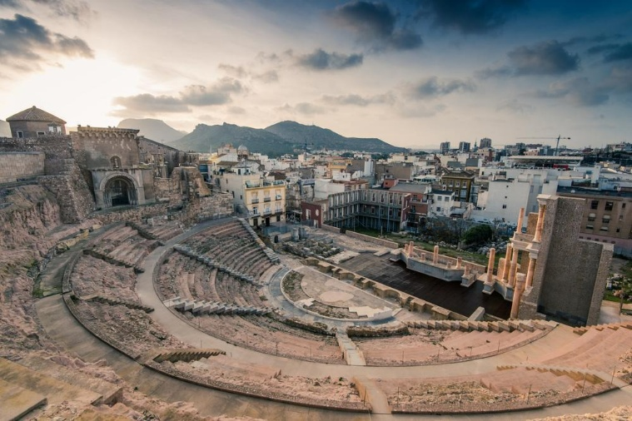
Figure 1 Roman theatre. Cartagena, Spain.
Tables must be centred within the column. Vertical borders should not be used. Each table shall include a caption placed above the table, written in 10.5-point Times New Roman font, centred, and formatted using the predefined style “Caption”. An example of a table is provided in Table 1.

Table 1. Density of solid and fluid materials
Material |  | Density, kg/m³
Air |  | 1.21
Water |  | 1000
Steel |  | 7850

Equations
Equations shall be formatted using the appropriate equation editor provided by the word processing software. An example is
$E=mc^{2}$. | (1)
Each equation must be placed within a two-column table with no edges of total width 160 mm. The left column (150 mm wide) shall contain the equation, while the right column shall contain the equation number in parentheses.
Both the equation and its corresponding number must be centred vertically and horizontally within their respective cells. The font used for equations shall be Times New Roman, 10.5-point.

References
All bibliographical references shall be listed in a section entitled “References”, numbered in order of appearance in the text, following the IEEETR bibliography style. All references included in the list must be cited in the main text. References shall be cited using square brackets, e.g. [1],[1] and [3]. The predefined style “References” must be used for all entries. The font shall be Times New Roman, 10.5-point.

OTHER IMPORTANT INFORMATION

Intellectual Property
Authors must obtain permission from the relevant intellectual property holders before publishing or reproducing any figures, images, or other copyrighted material in their manuscript. A statement confirming that such permission has been obtained must be included in the manuscript, where appropriate.

Submission of Papers
All extended abstracts must be submitted online as unprotected PDF files via the conference website: https://saat2026.org/saat2026/abstracts/submission. Authors must follow the submission guidelines provided on the website.
The file size of the manuscript must not exceed 10 megabytes, and the length must not exceed four pages. Manuscripts that do not conform to the formatting requirements specified in this template will be returned to the author(s) for revision. Only papers that comply with these guidelines will be included in the Proceedings.
The deadline for submission of the complete manuscript is 18 September 2026. Papers will only be considered if the PDF file has been successfully uploaded via the conference website.
The corresponding author (i.e. the author who submitted the abstract) will receive an email confirmation upon successful submission. If confirmation is not received within 24 hours, authors should notify the organisers by email at: congresosA10@viajeseci.es.

Mandatory Registration of Authors
An invited or contributed paper may be included in the Conference programme and Proceedings only if the corresponding registration fee has been paid by the deadline for submission to the Proceedings.
Each registration fee covers two papers only. If the same author submits more papers, an “Additional paper” fee must be paid for each extra submission.

CONVERSION TO PDF
Authors must carefully check the final PDF file prior to submission to ensure that the conversion has been completed correctly and that no errors occur when opening the file. Common issues include missing or incorrectly rendered symbols (particularly mathematical notation), improper display of figures, and incomplete or distorted figure captions. It is the sole responsibility of the authors to identify and correct such problems before submission.

ACKNOWLEDGEMENTS
Authors may acknowledge financial or other forms of support in this section. All acknowledgements must be placed after the “Conclusions” section and before the “References” section. The headings “Acknowledgements” and “References” should not be numbered and must be formatted using the predefined style “Header no numbering”.

REFERENCES
- J. H. Rindel, Sound insulation in buildings. Boca Raton, USA: CRC Press, 2018.
- N. Prodi and R. Pompoli, “Acoustics in the restoration of Italian historical opera houses: A review”, Journal of Cultural Heritage, vol. 21, pp. 915-921, 2016.
- M. Vorländer and I. Muhammad, “Real-time auralization of sound insulation”, In INTER-NOISE and NOISE-CON Congress and Conference Proceedings, pp. 614-621, 2018.

