Contribution Title
THE MAXIMUM NUMBER OF PAGES IS SIX (including references. Please, consider that in the final version, it may be necessary to include Acknowledgments and Ethical Approval sections). The paper should contain the following sections.
Abstract. The abstract should summarize in a single paragraph the contents of the paper in short terms, i.e. 150-250 words. Mathematical notation should be avoided as far as possible.
Keywords: First Keyword, Second Keyword, Third Keyword.
- First Section
  - A Subsection Sample
Please note that the first paragraph of a section or subsection is not indented. The first paragraph that follows a table, figure, equation etc. does not have an indent, either.
Subsequent paragraphs, however, are indented.
The main words in all headings (even run-in headings) begin with a capital letter. Articles, conjunctions and prepositions are the only words which should begin with a lower-case letter.

Sample Heading (Third Level). Only two levels of headings should be numbered. Lower levels headings remain unnumbered; they are formatted as run-in headings.

Sample Heading (Forth Level). The contribution should contain no more than four levels of headings. The following Table 1 gives a summary of all heading levels.
Table 1. Table captions should be placed above the tables. Note that “Table” and the table number are in bold, while the rest of the legend is not. Short captions are centered, while long ones are justified. Captions that do not constitute a full sentence, do not have a period.
Heading level | Example | Font size and style
Title (centered) | Lecture Notes | 14 point, bold
1st-level heading | 1 Introduction | 12 point, bold
2nd-level heading | 2.1 Printing Area | 10 point, bold
3rd-level heading | Run-in Heading in Bold. Text follows | 10 point, bold
4th-level heading | Lowest Level Heading. Text follows | 10 point, italic
Only the first word (as well as any proper nouns or abbreviations) in tables and figures titles should begin with a capital letter. Make sure that tables and equations are editable, in case your paper needs to be reformatted or corrections made.
If you have a particularly wide table, please do not change the orientation of the page from portrait to landscape. Instead, create the table with its top row parallel with the left margin and its bottom row parallel with the right margin of the page. The legend should run parallel to the top row.
Displayed equations are centered and set on a separate line.
x + y = z (1)
Lists should either use the “Numbered Item Text” or “Bullet Item Text” styles.
- Unnumbered lists should use the “Bullet Item Text” style.
- Unnumbered lists should use the “Bullet Item Text” style.
Please do not leave large gaps at the bottom of a page (Fig. 1). If a figure or table will not fit on the space left on a page, reposition the figure so that it appears at a more convenient place in the text.
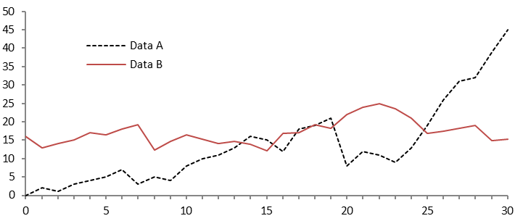Fig. 1. A figure caption is always placed below the illustration. Note that “Fig.” and the figure number are in bold, while the rest of the legend is not. Short captions are centered, while long ones are justified. Captions that do not constitute a full sentence, do not have a period.
For citations of references, it is preferred the use of square brackets and consecutive numbers. Citations using labels or the author/year convention are also acceptable. Please, note the following examples: Single citation: [9]; Multiple citation: [4-6, 9]; If an author’s name is used in the text: Miller [9] was the first …
The “References” section provides a sample reference list with entries for journal articles [1], an LNCS chapter [2], a book [3], proceedings without editors [4], as well as a URL [5]. It is strongly encouraged to include DOIs in the references.

References
- Author, F.: Article title. Journal 2(5), 99–110 (2016).
- Author, F., Author, S.: Title of a proceedings paper. In: Editor, F., Editor, S. (eds.) CONFERENCE 2016, LNCS, vol. 9999, pp. 1–13. Springer, Heidelberg (2016).
- Author, F., Author, S., Author, T.: Book title. 2nd edn. Publisher, Location (1999).
- Author, F.: Contribution title. In: 9th International Proceedings on Proceedings, pp. 1–2. Publisher, Location (2010).
- LNCS Homepage, http://www.springer.com/lncs, last accessed 2016/11/21.

