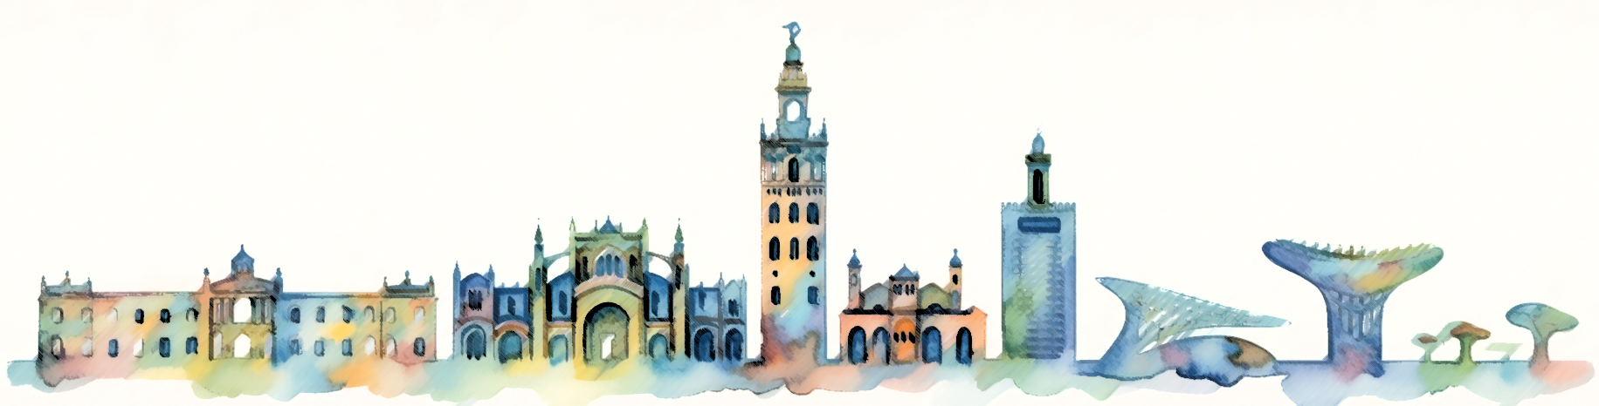
II SEBP ALGAE Symposium
IBVF Plant Biochemistry and Photosynthesis Institute
1-2 June 2026, Sevilla

ABSTRACT

Title here, Nunito, bold, 16 points

Author 1¹(Name Family name), Author 2 ²,… (Nunito, 12 pt, Presenting Author underlined)

1) Affiliation 1; 2) Affiliation 2;… (Nunito, 11 pt)
Body text (Nunito, 11 points, justified; 1,15 line spacing).References, if any, in superscript with Arabic numbers

- Abstract
The abstract must be written in English (nunito, 11 points, justified; 1,15 line spacing) with a maximum length of 2000 characters including spaces in order to not exceed ONE page (including References and Acknowledgements, if any).
Figures, tables and images should not be included.
The text inserted in this word template will be included in the abstract book without any modification or editing.
Save the abstract in Word format as “NAMESURNAME_abstract” of the presenting author.

References
- Calibri, 10 pt, sequentially numbered in Arabic, justified, ACS style is suggested, i.e: Author, A.; Author, B. Journal Acronym year, volume, initial page-final page (ACS style).
- …

Acknowledgements
Nunito, 10 pt

